Flag Raising Ceremony

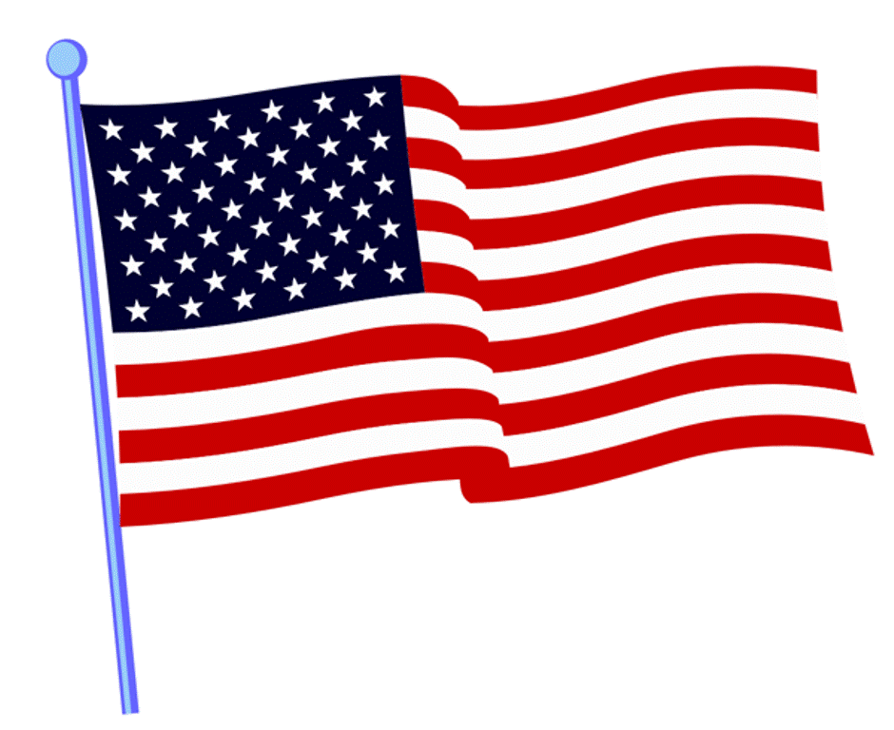
Overview: This Flag Raising ceremony can be performed at the start of a major event such as a weekend campout or each day at sunrise as desired.
There should be a pre-folded flag ready for raising on a flagpole. Flag bearers are chosen. Another option would be to have a procession from where the flag is unfurled to where it is raised.
Honor and respect during this ceremony are important and should be taught and encouraged.
The use of ceremonial drums during this ceremony is also an honorable addition and adds to the connection between our country and the Native American culture.

Participants:
- Longhouse Chief, or other as the ceremonial leader.
- Assistants as desired.
- Drumbeater(s)

Flag Raising Ceremony
(Drum Beats until signaled to stop)
LEADER:
(Shouts Longhouse Salutation)
Welcome to this gathering. We honor our nation and give thanks to the Great Spirit for all the good gifts in life that we are blessed with as we raise the flag of these United States of America.
(Flag Bearers unfold or carry in flag)
(As flag is raised, sing the song America (My Country Tis of Thee) or America the Beautiful. This can be led acapella by one brave person or sung to a recording. )

LEADER:
Let us all recite the Pledge to the Flag of our Country:
I Pledge Allegiance to the flag, of the United States of America
and to the Republic for which it stands, one Nation under God,
indivisible, with liberty and justice for all.

What is the slogan of the Native Sons & Daughters Programs?
“Pal’s Forever-Friends Always”!

Let Us Recite the Six Aims of the Native Sons & Daughters Programs… repeat after me:
- To be clean in body and pure in heart
- To be Pals Forever-Friends Always, father and son
- To love the sacred circle of the family
- To listen while others speak
- To love my neighbor as myself
- To seek and preserve, the beauty of the Great Spirit’s work, in forest, field and stream

(Play audio recording of The Star Spangled Banner. Encourage all to sing along)
Oh, say can you see by the dawn's early light, what so proudly we hailed at the twilight's last gleaming. Whose broad stripes and bright stars, through the perilous fight, O'er the ramparts we watched were so gallantly streaming… And the rocket's red glare, the bombs bursting in air, gave proof through the night that our flag was still there… Oh, say does that star-spangled-banner yet wave… O'er the land of the free and the home of the brave.

May the Great Spirit make sunrise in your heart! (Shout Longhouse Salutation)
(Drumbeats as everyone leaves)

